

**&**



**HireHonest and SmartRecruiters integration user guide**

*September 29, 2024*

**Key features of the integration**

1. **Aims to replace the deprecated v1 integration**
2. **The new integration will automate the order assessment process, streamlining operations and allowing for faster decision-making**
3. **The integration will lead to significant positive outcomes, including increased efficiency, reduced processing times, and improved accuracy in order assessments, ultimately enhancing the overall customer experience.**
4. **The transition from the deprecated v1 integration to our new and improved v2 integration will enhance performance, improve security, and provide a more seamless user experience.**

**Step-by-step instructions on how to setup the integration**

1. **Integration setup and enablement in HireHonest platform**
   1. **No need to do anything from a user standpoint. Setup will be done through back office/admin operation.**
2. **Integration setup and enablement in SmartRecruiters platform.**
   1. **Enabling integration via the Apps & Integrations page** 
      1. **Go to Settings > Apps and Integrations and look for HireHonest and select/click. **
      2. **Click Connect.** 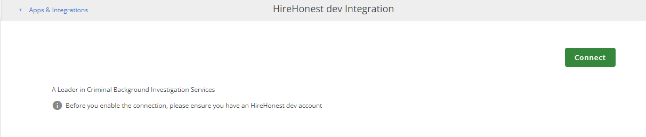
      3. **Click Allow and continue.** This will redirect the user to HireHonest platform and ask for credentials.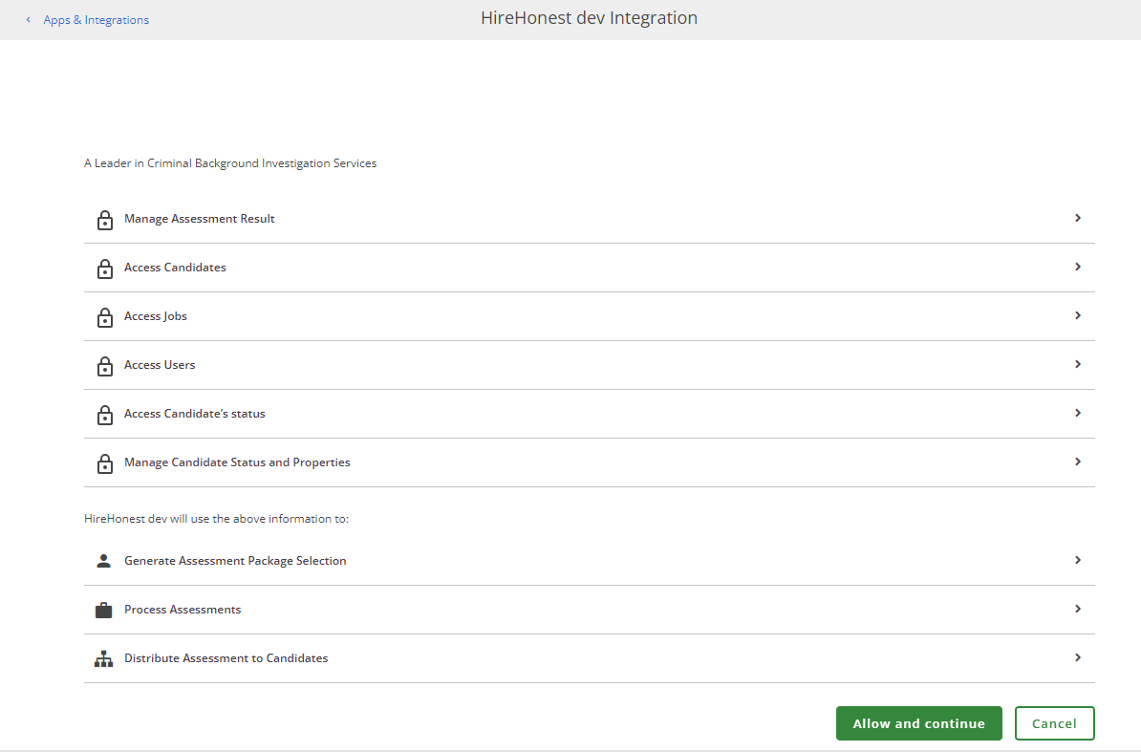
      4. **Login with your HireHonest credentials.** 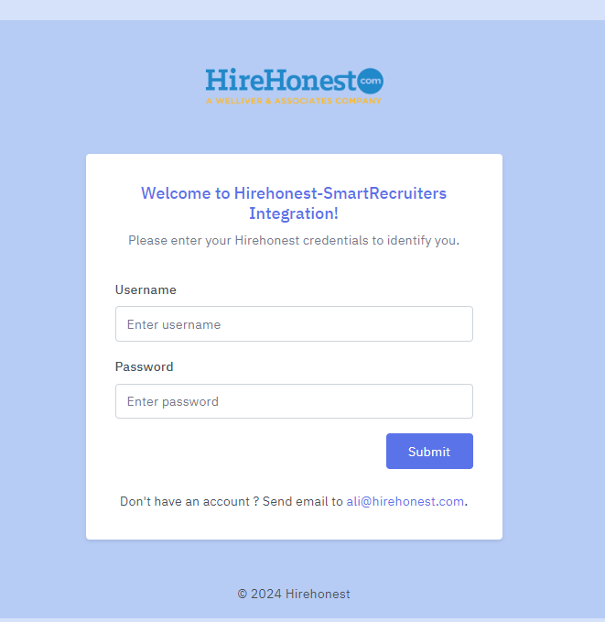
      5. **A successful login will then prompt the user to re-confirm that he/she allows HireHonest to make changes as listed areas and thus complete the integration.**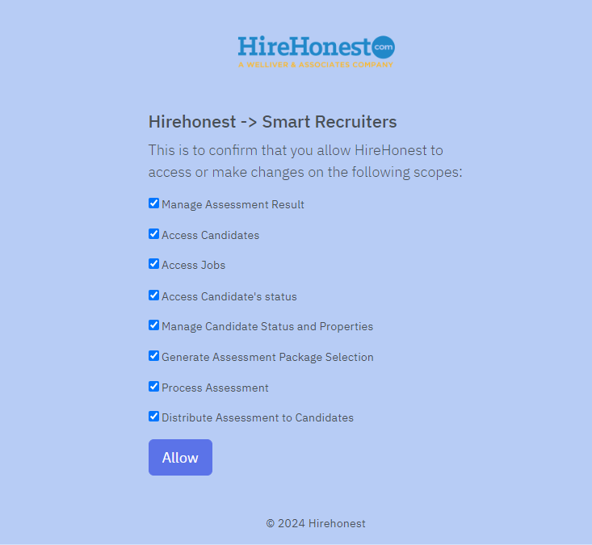
      6. **Clicking allow will then redirect the user back to the SmartRecruiters confirmation page, indicating the successful connection.**

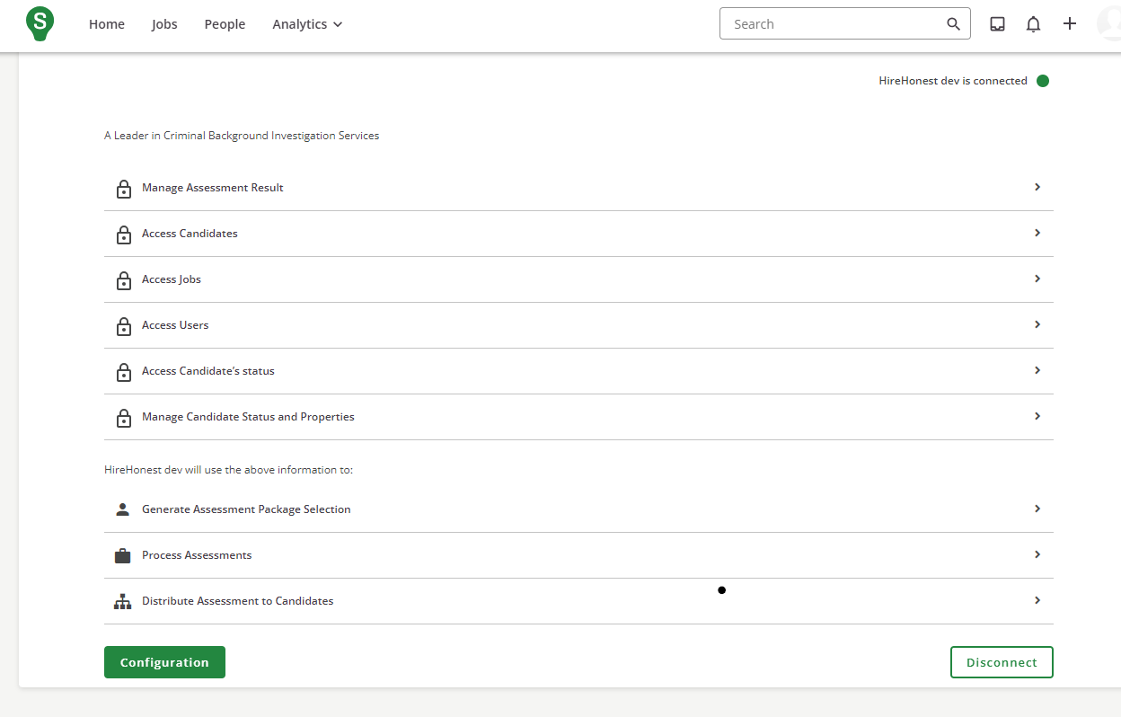

**Integration workflow**

1. **User triggers the HireHonest assessment order from SmartRecruiters**
   1. **User manually triggers the assessment order** 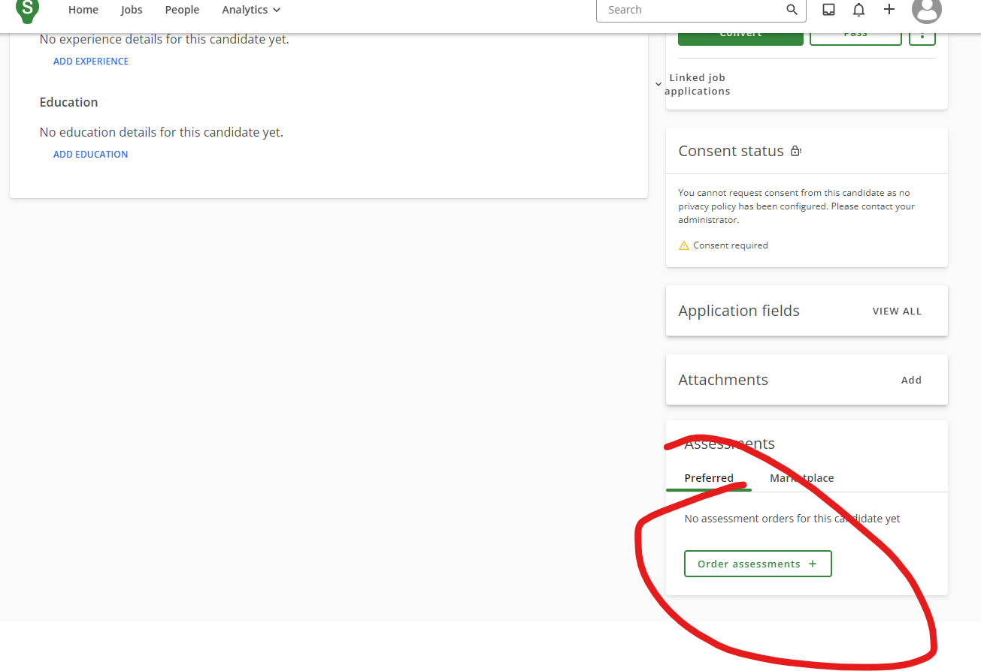
2. **SmartRecruiter calls the HireHonest package listing endpoint to get the list of assessment packages.** 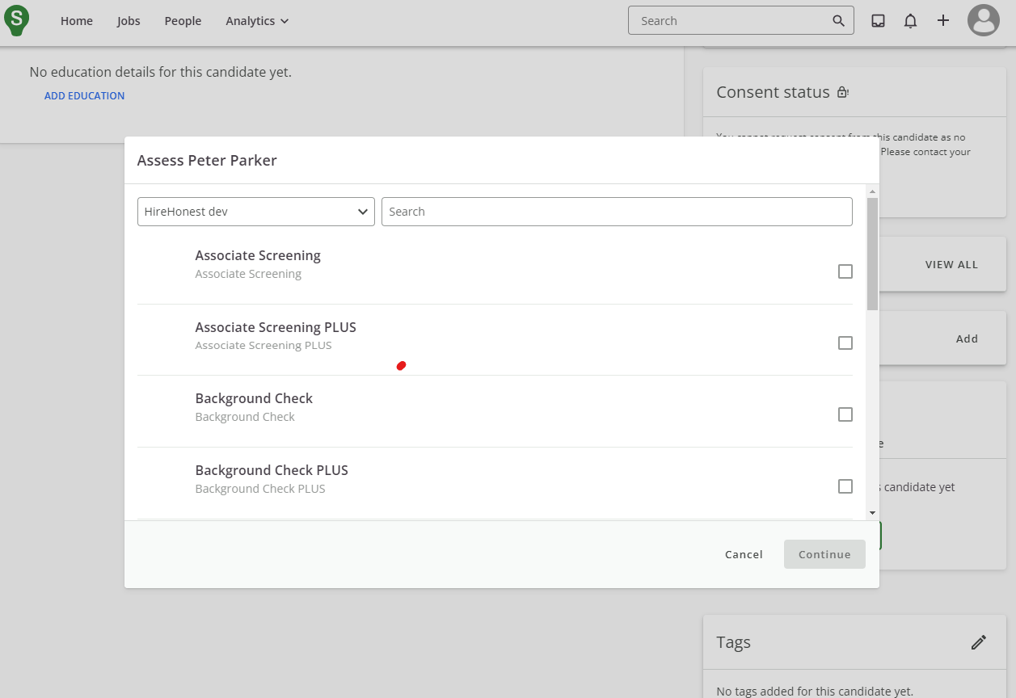
3. The user selects a package from the list and then clicks continue. 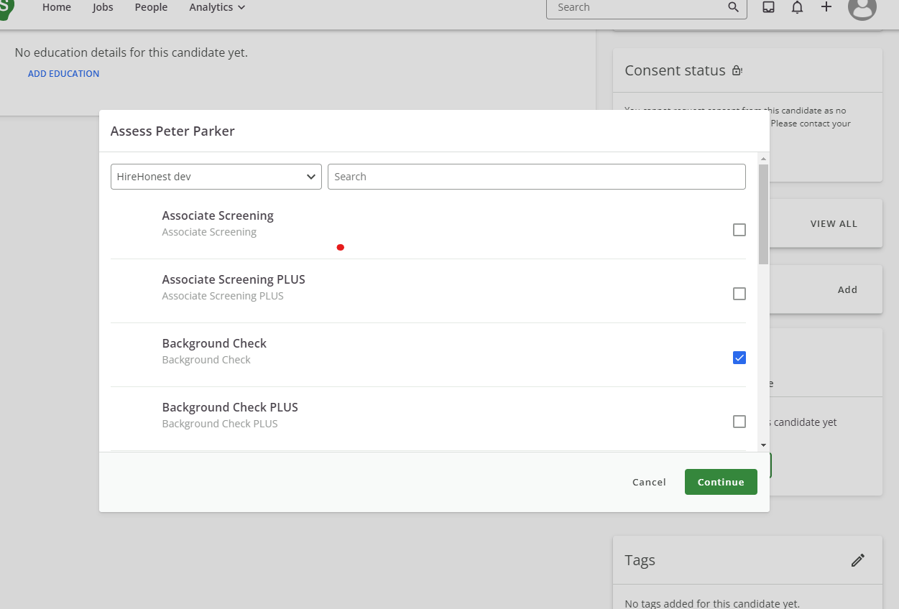
4. **Confirm the assessment package selected and click send.** 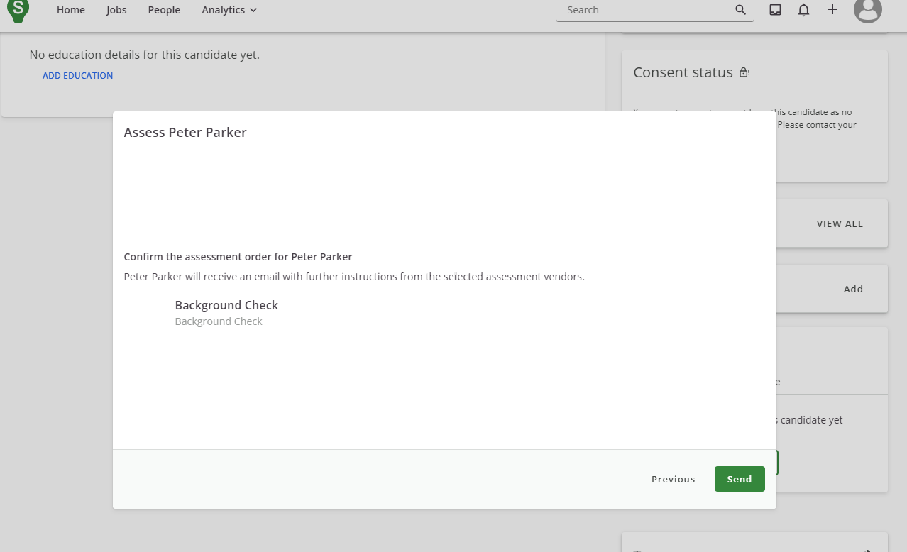
5. **SmartRecruiter calls the endpoint to create the Order from the selected package.**
   1. **An order will then be created.**
   2. **HireHonest sends an email to the candidate with a link so the candidate can supply the necessary personal information so a background check can be carried out. (SSN, Address, Birthdate etc.)** 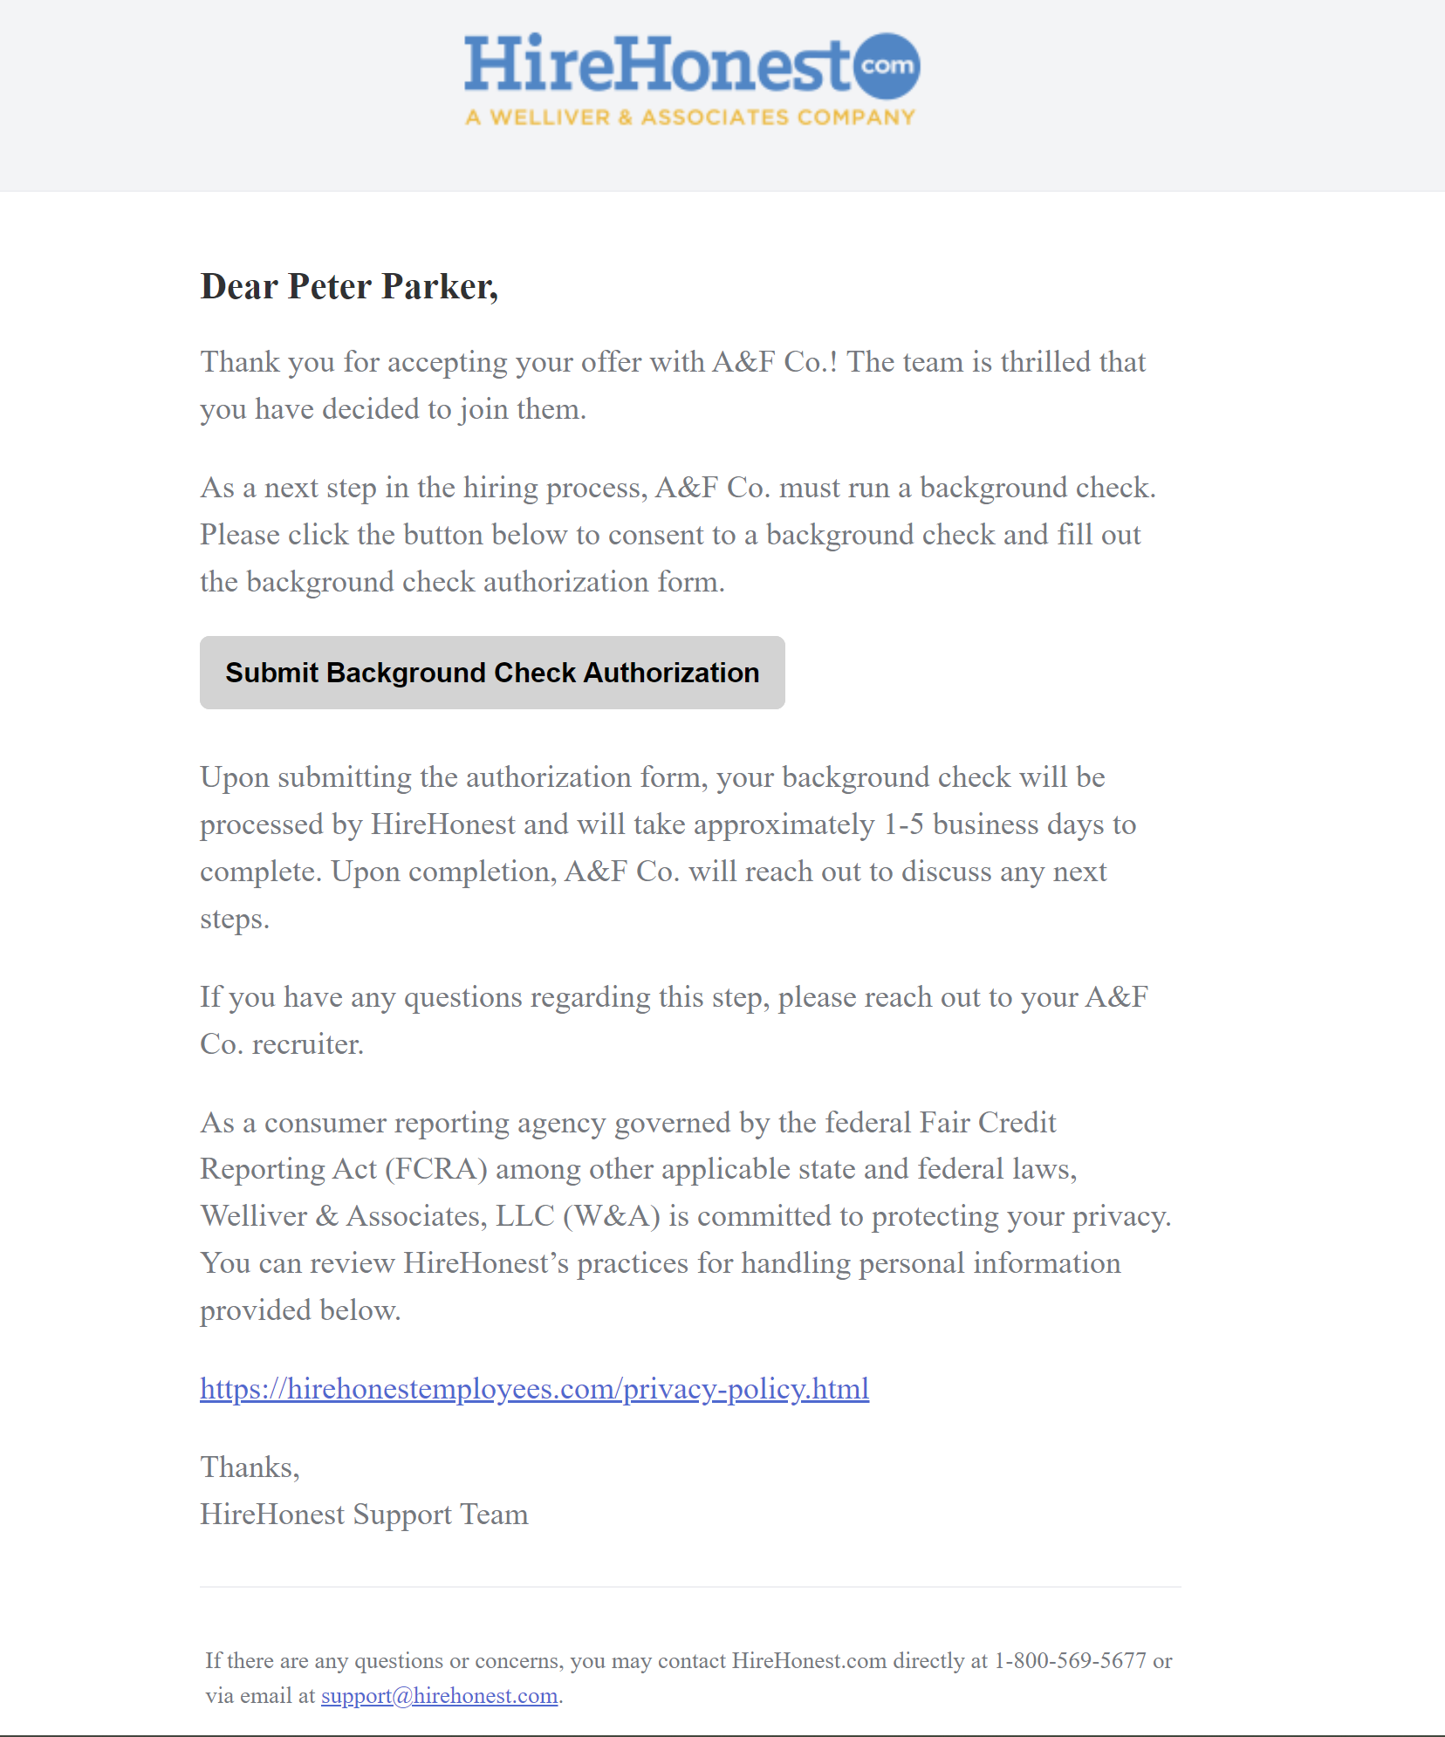
   3. **The candidate agrees and authorizes or consents to HireHonest for collecting personal data.** **The user then submits the form.**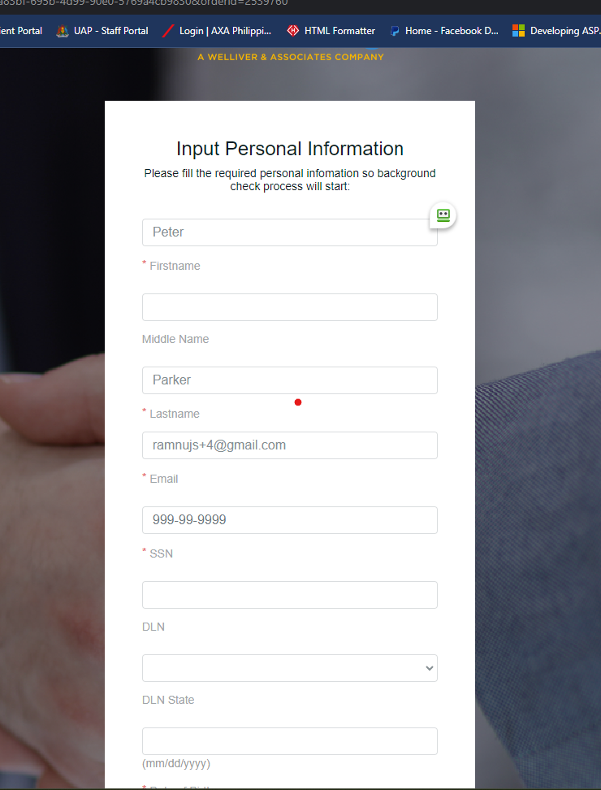
   4. **The candidate then acknowledges the FCRA.** 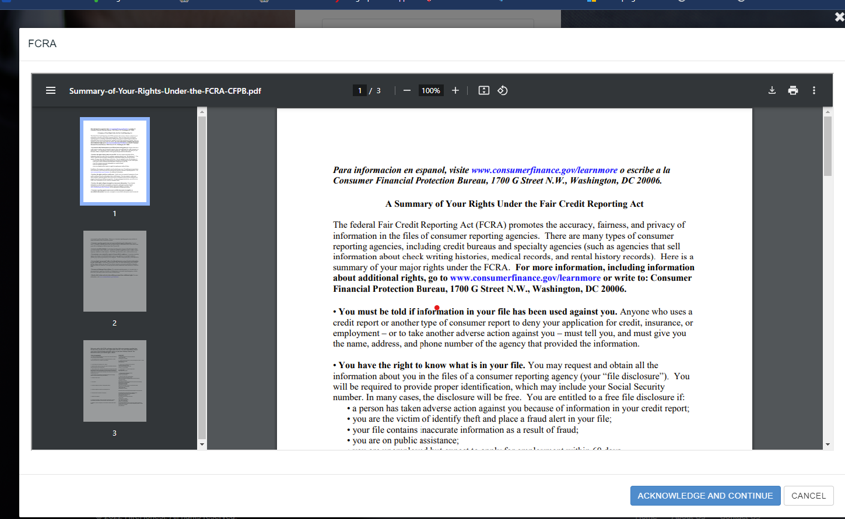
   5. **Candidate has to agree on the Disclosure of Intent To Obtain investigative consumer report for employment purposes.** 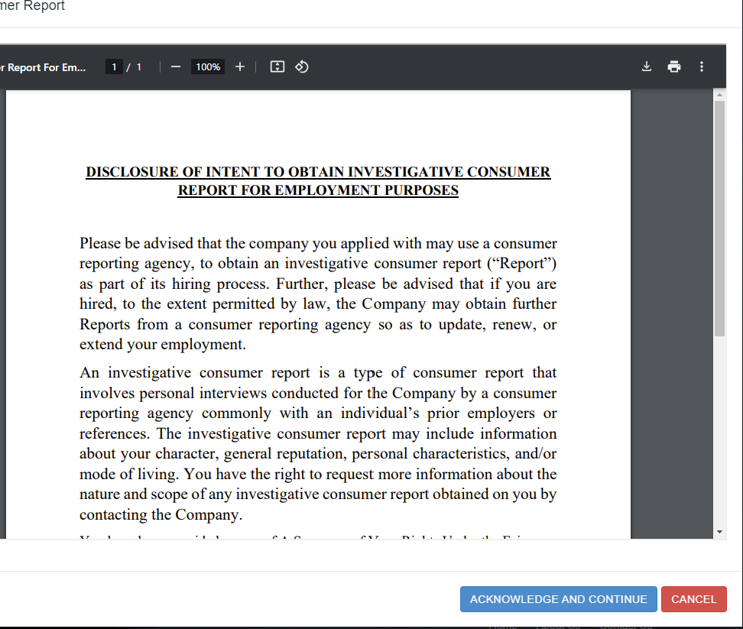
   6. **A successful submission will then be redirected to a confirmation page.**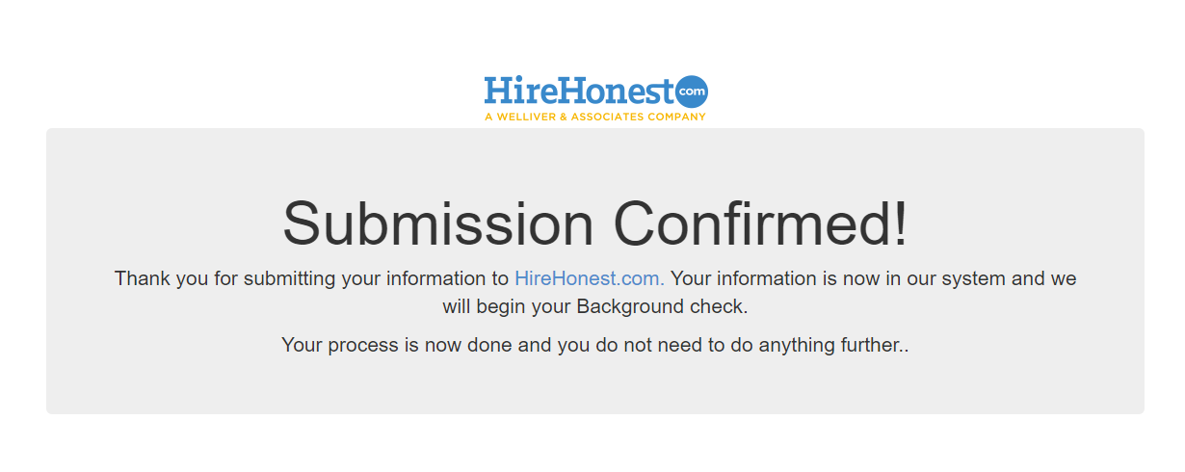
6. **HireHonest calls the SmartRecuiter endpoint to update the status to “IN_PROGRESS”.**
7. **HireHonest conducts investigations and background checks.**
   1. **If no criminal record is found, update the candidate's job status to “OFFERED” and sub status to “Background Check Passed” and complete the order.** 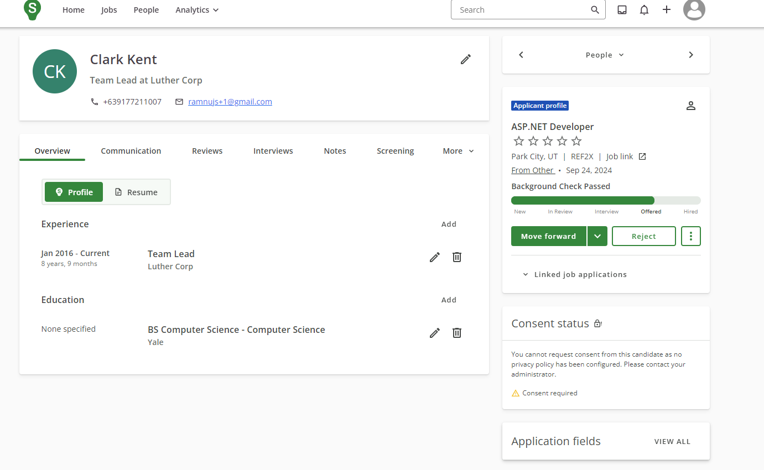
   2. **If criminal records are found, update the candidate's job status “Offered” and sub-status “Background Check Needs Review”** 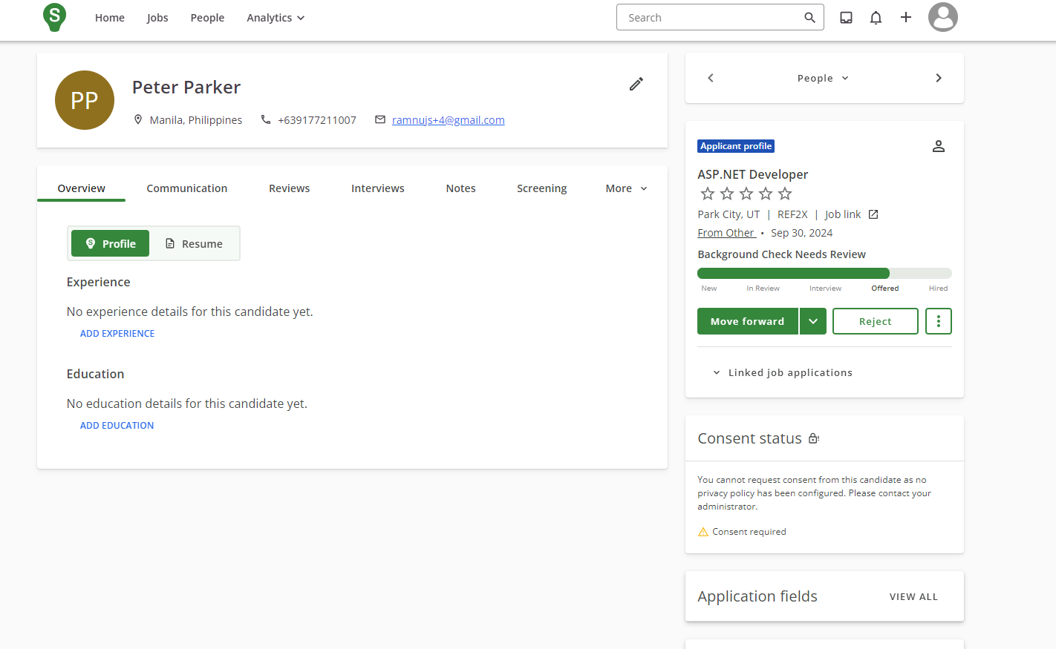
8. **Set the Crime Classification if applicable.**
9. **Set the Assessment status to “COMPLETED”**
10. **If the job status sub-status is “Background Check Needs Review”**
    1. **The client user will then log in to HireHonest client portal, open the order, and decide whether or not to pass or fail the candidate.**

**Potential limitations/requirements**

* **The integration will only work with candidates/jobs in USA,**

**Support Contact**

**For any integration issues, please contact** [**jun@hirehonest.com**](mailto:jun@hirehonest.com)**, ali@hirehonest.com.**