

&

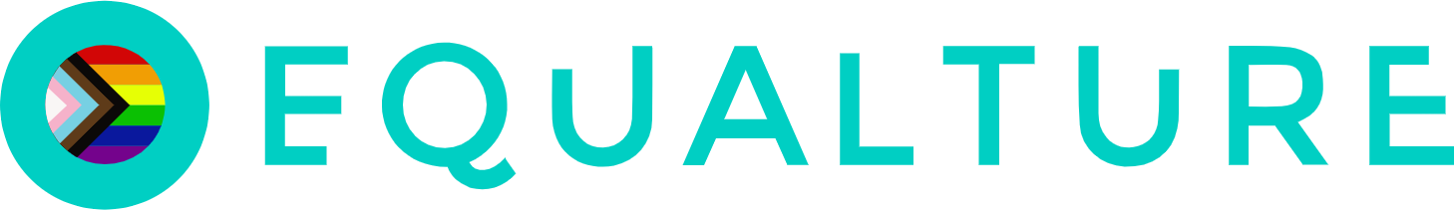

Equalture and SmartRecruiters integration user guide

*24/05/2024*

Key features of the integration

Through this integration, you can send Equalture assessment tests to candidates via SmartRecruiters and receive the results on the candidate's profile in SmartRecruiters.

Equalture’s game-based assessment platform allows you to act on scientific insights. We help you hire fairly and objectively by collecting crucial insights on both your current team and candidates.

Leverage Equalture’s neuroscientific games in three easy steps:

**Step 1.**

Define your ideal hire by using the Team analysis feature to set the right benchmarks.

**Step 2.**

Collect the right candidate insights by letting all your applicants run through the games and receive easy-to-interpret candidate reports.

**Step. 3.**

Objectively select the right candidate by sorting and filtering the candidates’ assessment results according to your benchmarks.

How to setup the integration

**IMPORTANT - Please reach out to your Equalture Customer Success Manager *first,* so we can provide you with the link to set up the integration.**

## **Part One: Generate your SmartRecruiters code**

Before getting started, please carefully read the following to make sure you fulfill all requirements for the integration to work:

* You should have "Admin Access" to your SmartRecruiters instance.  
  If your account does not have the assigned User role of "Admin" you won't be allowed to create the necessary credentials.

1. Log into SmartRecruiters and go to "[Settings](https://www.smartrecruiters.com/settings/home/)" in the top right corner: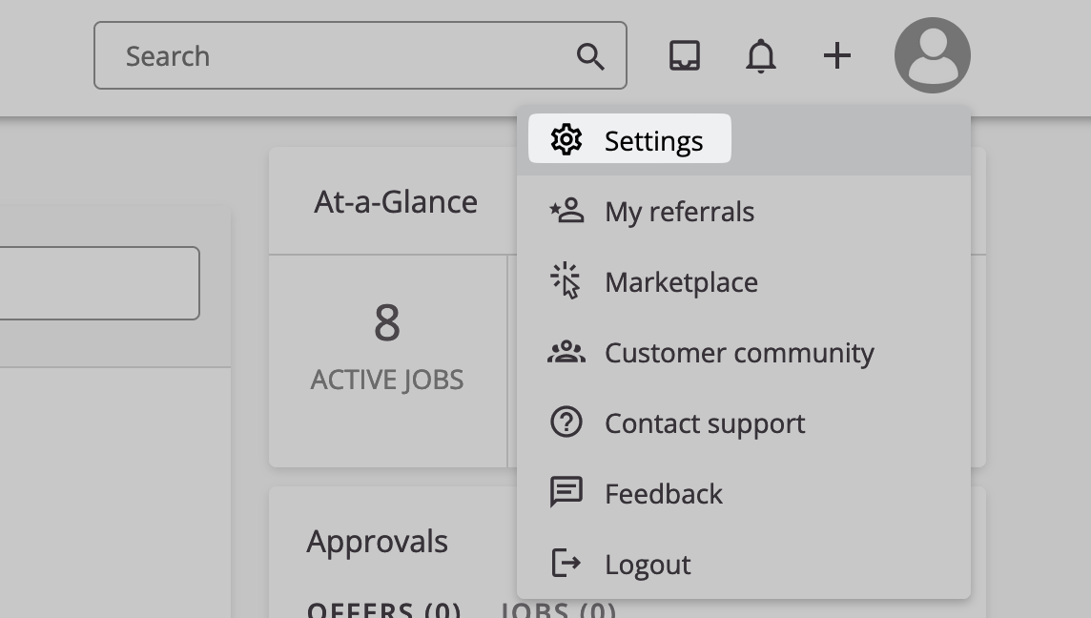
2. Ensure that your account is labeled with "Admin Access" underneath your account name: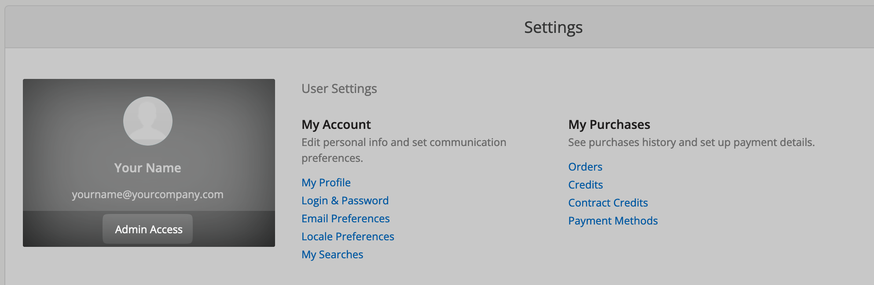

### **Sign in with SmartRecruiters**

1. Select “[Apps & Integrations](https://www.smartrecruiters.com/settings/administration/app-management)” from the “Administration” section in the SmartRecuiters settings.  
   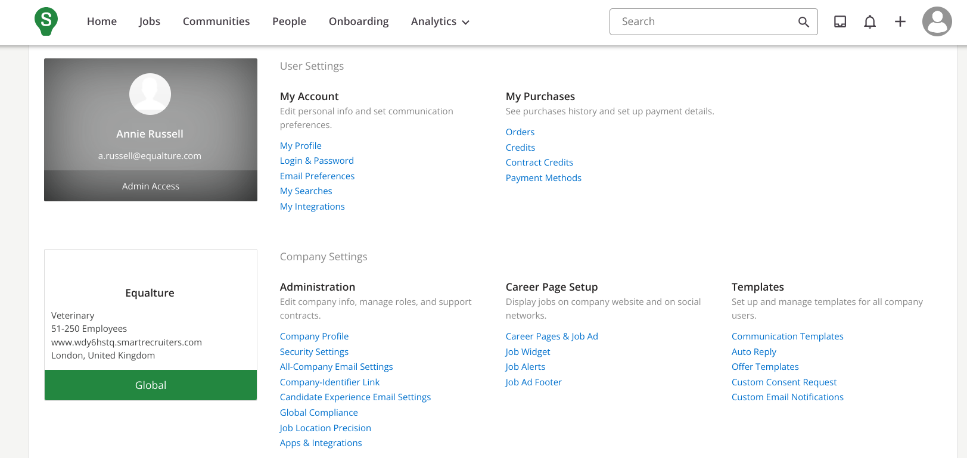
2. Find Equalture in the list and select this option -> Click on the name to open.  
   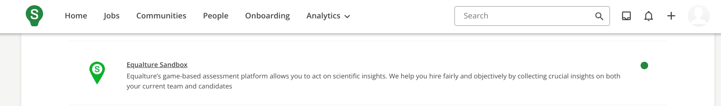
3. Click “Connect” in the top right corner   
   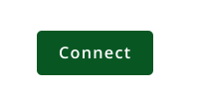
4. On the next screen, click you will find a code that is required for **Part Two** “The connection flow”. Make sure you copy this code.  
   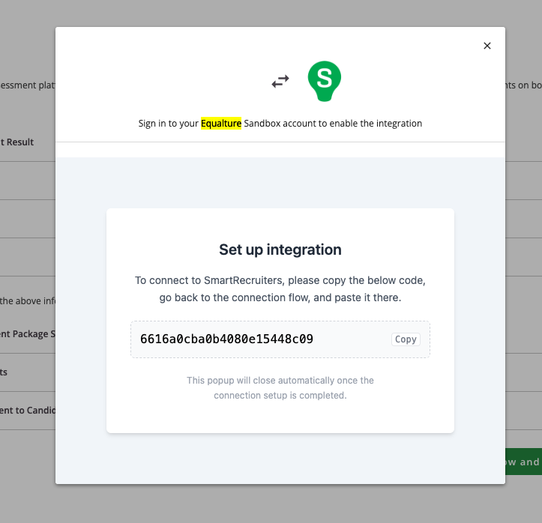

## **Part Two: The connection flow**

1. You will receive a link from your Customer Success Manager to set up the SmartRecruiters integration.
2. Click on the "Sign in with SmartRecruiters" button:  
   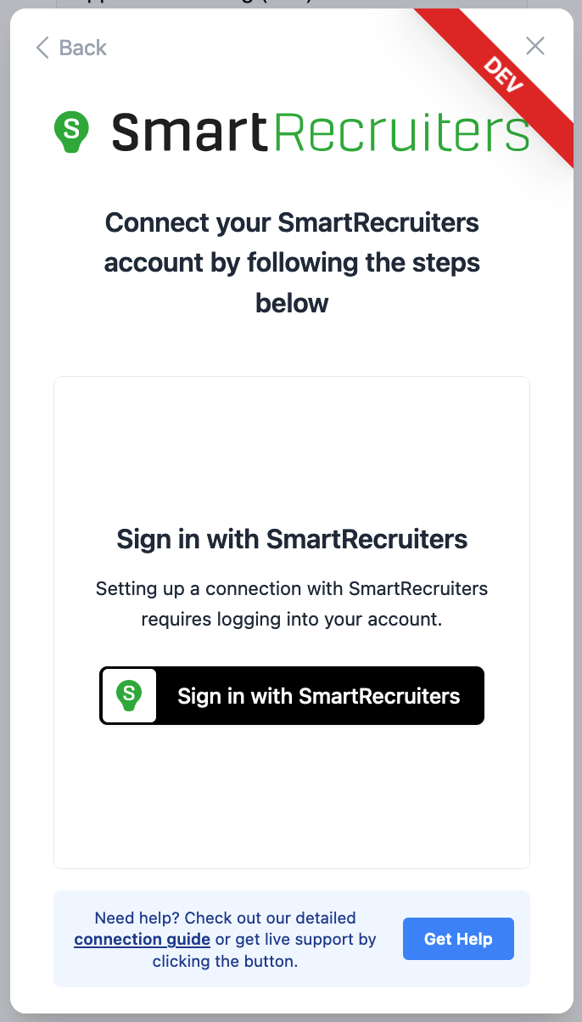
3. Logging in will lead you to the following page:  
   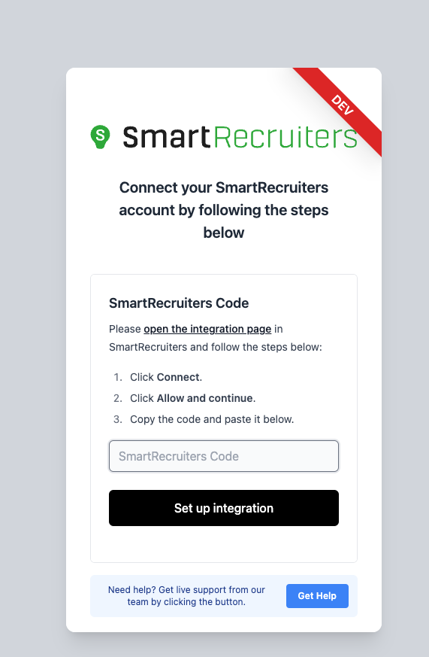
4. Enter the code from Step 1, and click “Set up integration”

Integration workflow

## [How to create an assessment in Equalture](https://support.equalture.com/en/articles/8450776-edit-share-close-a-job)

## **Add an assessment to your SmartRecruiters workflow**

1. From the SmartRecuiters settings page select the option “Hiring process”

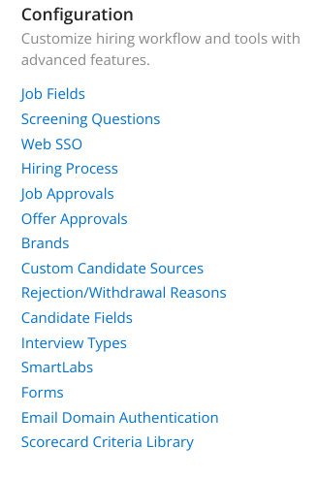

1. Click the “Edit” Icon

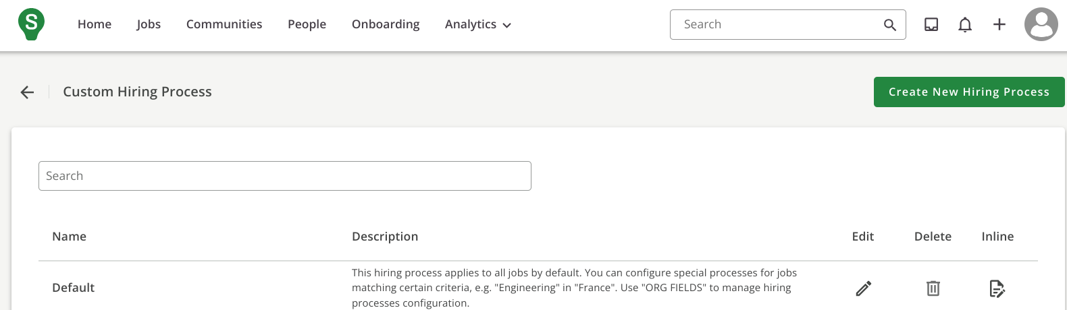

1. Click on stage you want to add an assessment to, and select “Assessments”  
   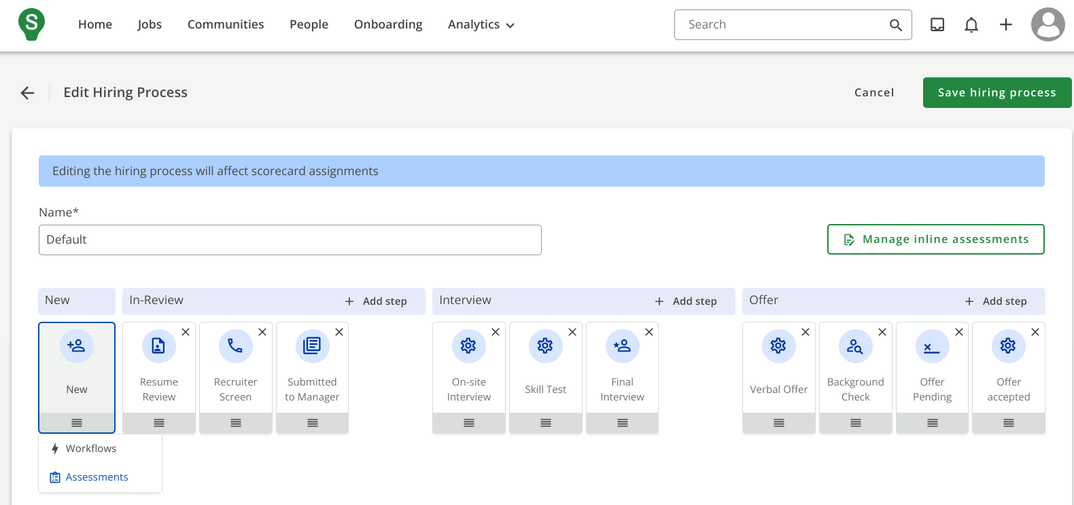
2. Search for the name of your assessment in Equalture and click “Configure”

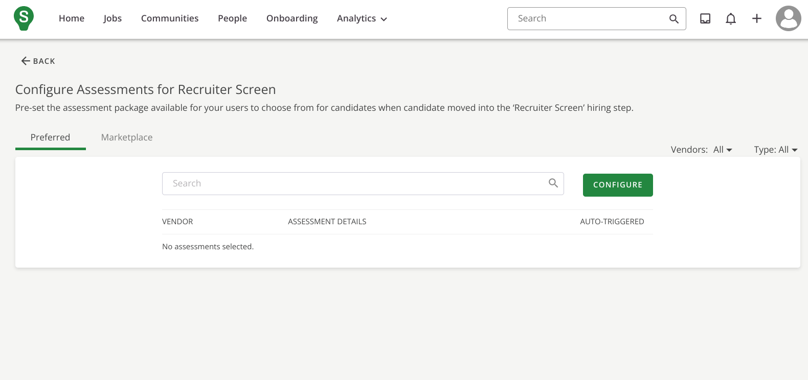

1. Mark the assessment as “active” and save

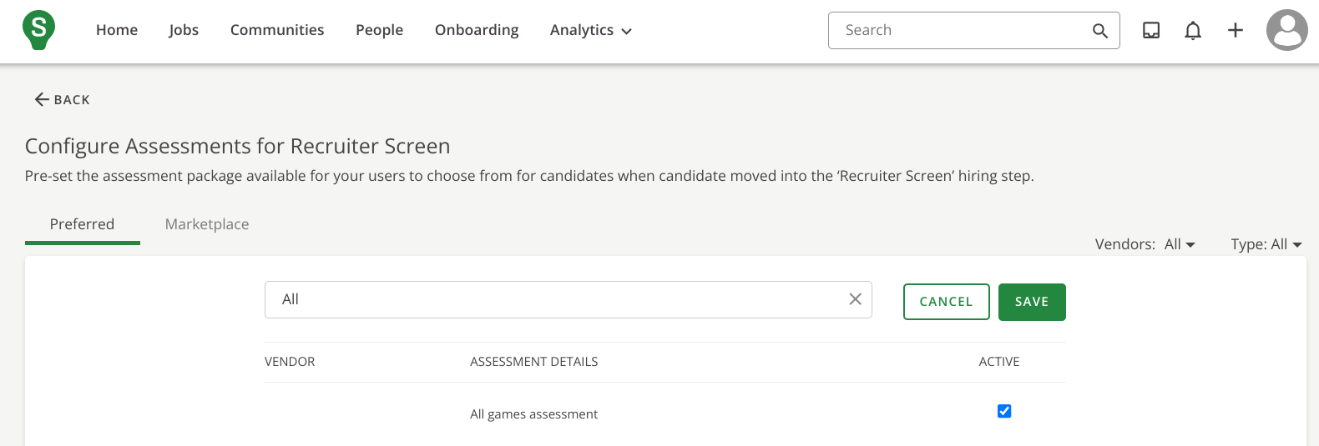

1. Turn on “auto-trigger” to automatically send this assessment when a candidate reaches this stage

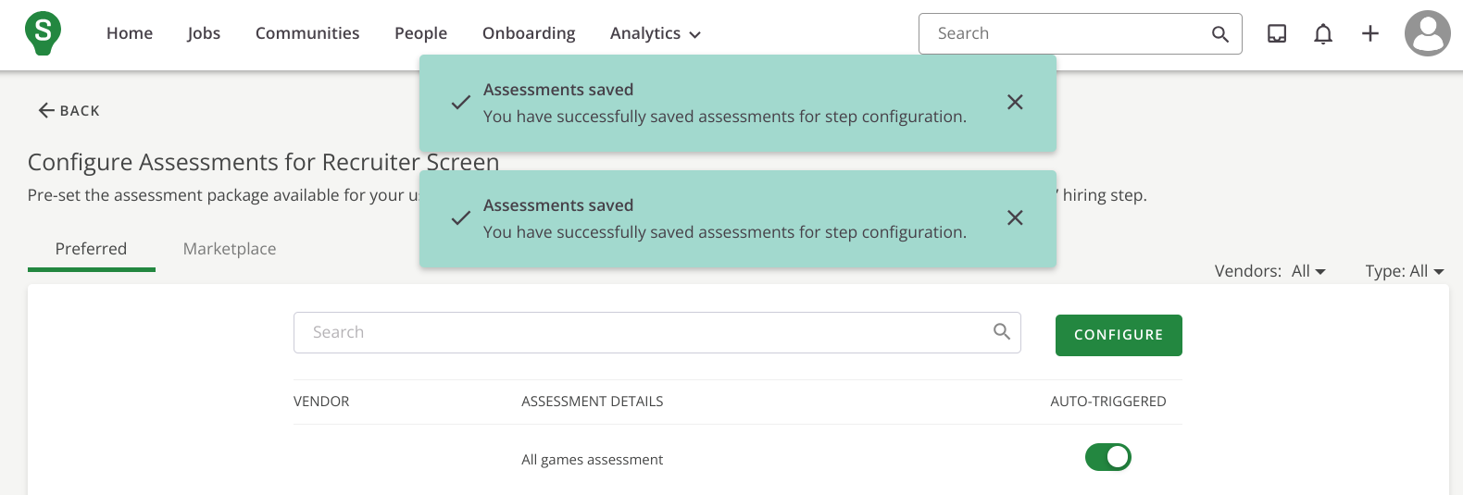

**How are the Equalture results presented in SmartRecruiters:**

1. Select the candidates profile on your SmartRecruiters job

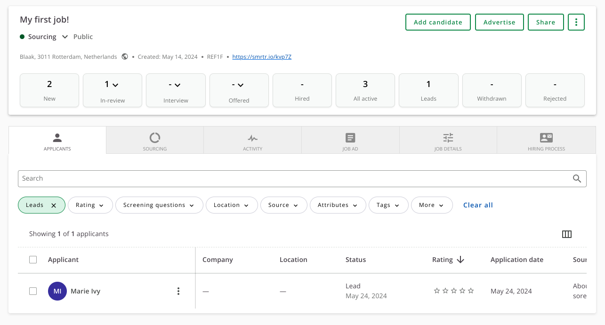

1. Once the assessment is ordered, you will see this under the “assessments” section in a Pending state.

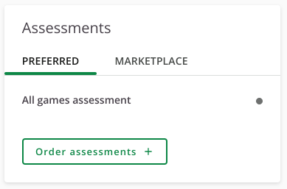

1. When the applicant has completed the assessment it will change to a completed state, and the applicant's results are attached.   
   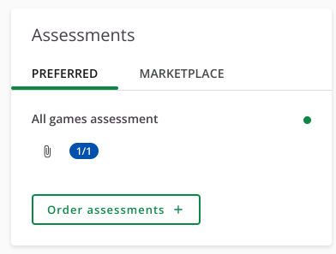
2. Click to view the attached candidate profile and game results.

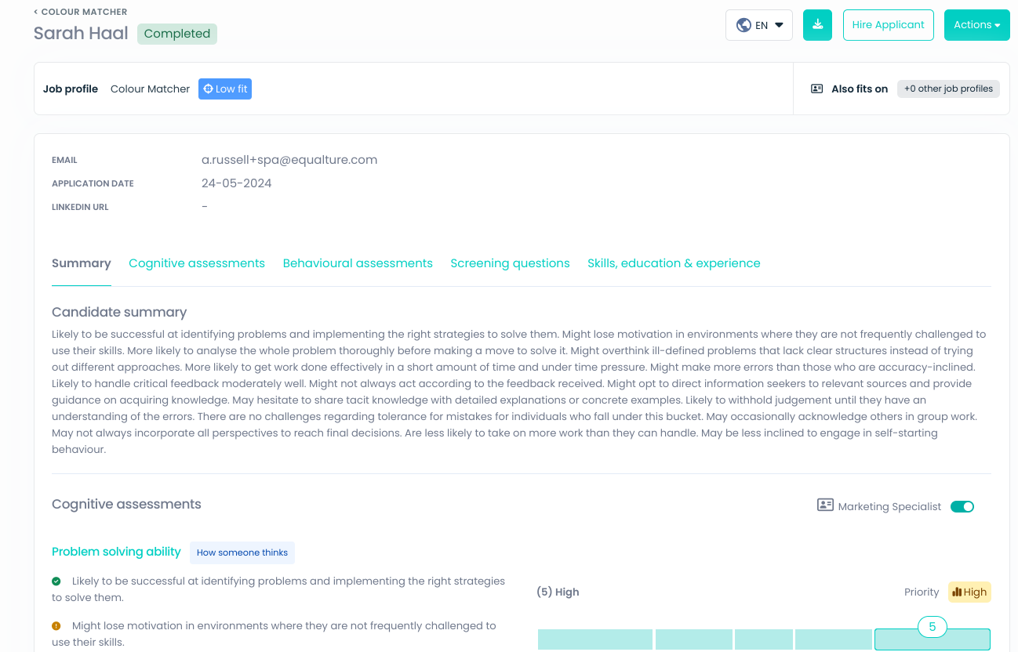

Support contact

Please contact our support team via your customer success manager or via the chat.