


Smart Recruiters – How to submit a background check

Justifacts Credential Verification, Inc.
Last Revised on 4/11/2024

After locating the candidate’s profile within your Smart Recruiters system, click the “BROWSE” button located in the Assessments panel.

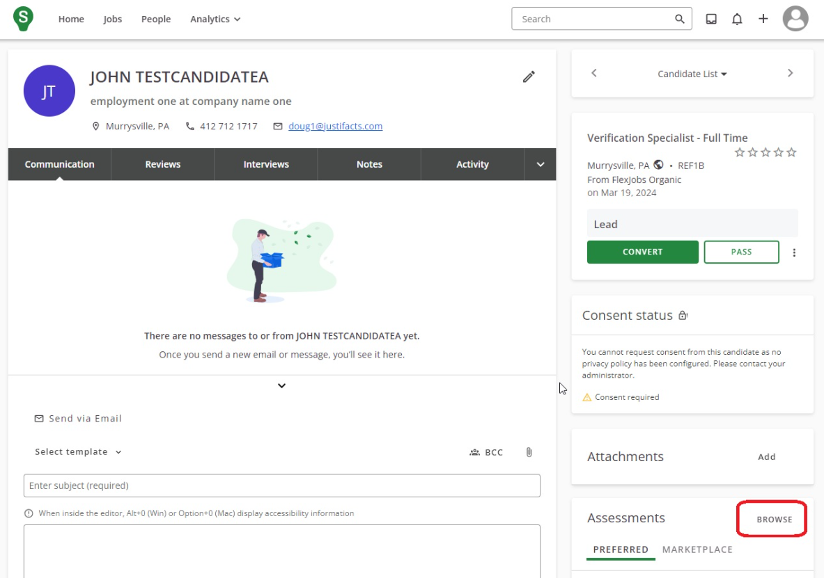

A pop-up window will appear displaying the available background screening packages and any package notes setup in your Justifacts account.

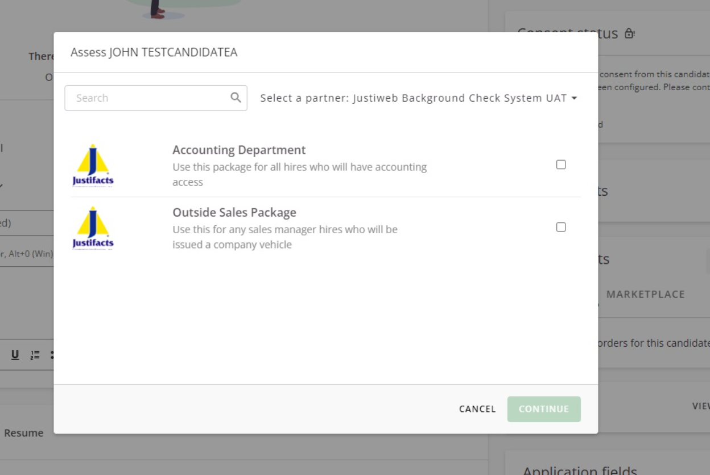

**To add additional packages, make package adjustments, or add package notes, please contact a member of your Justifacts account management team.

Select the background screening package that you would like to initiate on the candidate and click the “CONTINUE” button.

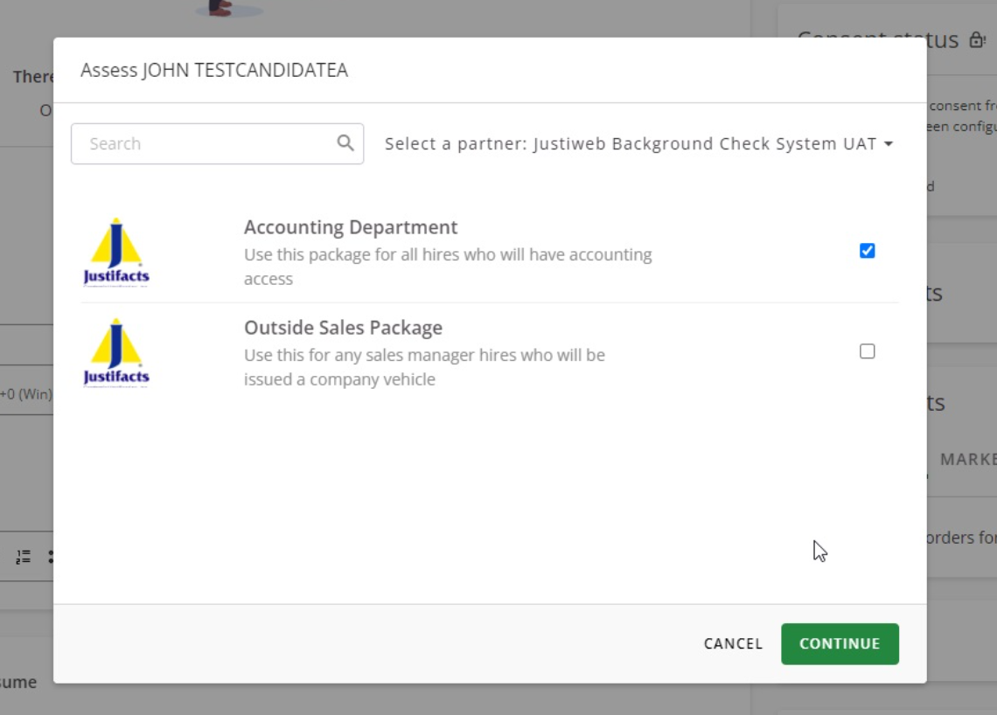

A confirmation window will appear requesting you to confirm that you would like to proceed with sending the authorization email from Justifacts to your candidate.

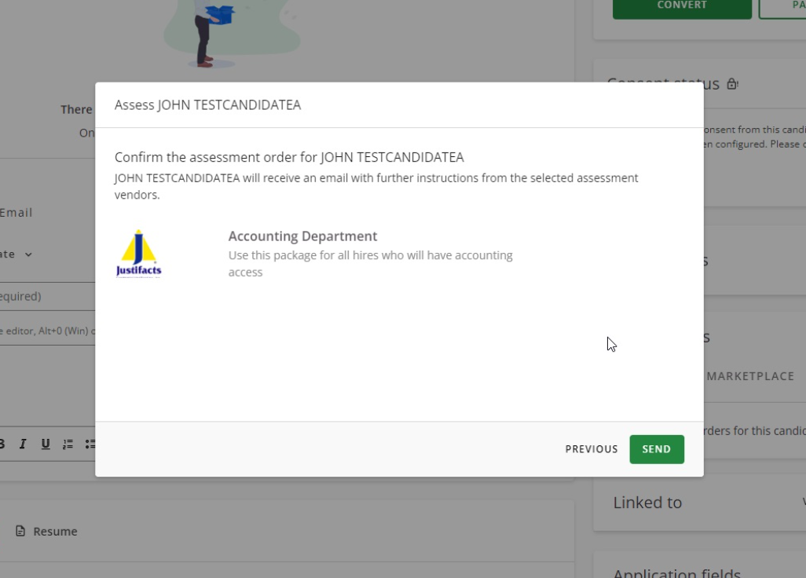

The candidate will have three days (unless the expiration is adjusted) to complete their authorization process. Once the candidate authorizes the background check, a report will be created and processed through the Justifacts system.

The Assessments panel will now display the background screening package that was requested.

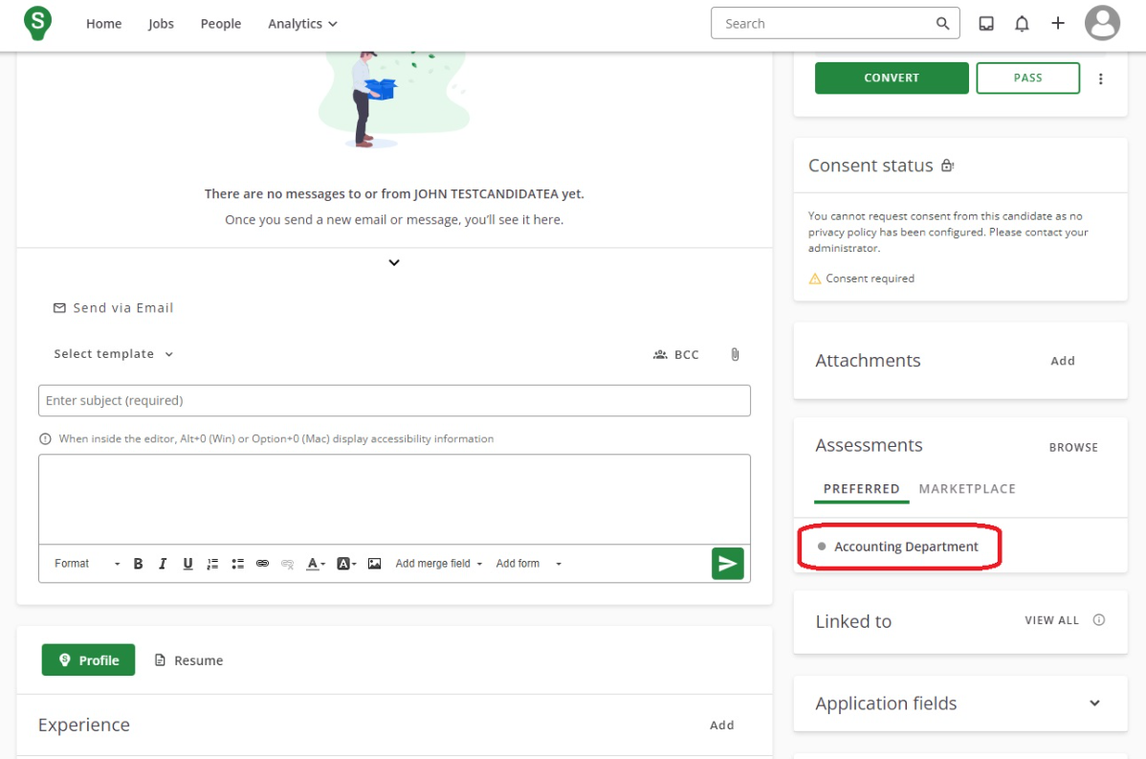

**You will receive email notices: If the candidate lets the authorization get to 24 hours until expiration, if the candidate allows the link to expire (which will include a button for you to reset the timer), when the background check has been started, and when the background check has been completed. Additional email notices are availble through your Justifacts profile settings.

Once the candidate completes the authorizatin process, a paperclip icon will appear in the Assessments panel to provide a link to the report in the Justifacts system. Additionally, a status of the report will be displayed next to the icon link.

